Influence of the Document Format on Final Aesthetic
Arrangement of the Proceedings as a Whole
Author¹⁾, co-author²⁾
VŠB – TU Ostrava, Katedra elektroenergetiky, 17. listopadu 15, 708 33 Ostrava, http://fei1.vsb.cz/kat410/
¹⁾ tel: +420 596 999 306 , email: lukas.prokop@vsb.cz ,
²⁾ tel: +420 596 994 554, email: radomir.gono@vsb.cz

Abstract
Because applications of templates, styles and formats defined are always connected with problems, a brief description how all is done and how it can be used for achieving the result required is given below.
In case you find this help and this explanation insufficient, please, contact one of the members of organizing Committee (Abstract as well as Keywords should be written in English.).
Formatting, Styles, Applications
- Introduction
Text formatting, and thus also the template are based on the international standard for the A4 format.
The purpose of this template and this description is the following:
- Standard typesetting the text in the A4 format,
- The uniform layout of all contributions,
- The aim of the description is to furnish the user with good quality information on necessities and possibilities of applying the template and the editor to achieve the required typesetting of the text.
- Template Application
Basic application procedures in relation to text formatting according to the template file *.dot in the MS WORD environment are presented briefly here, such as applications of type styles, the insertion of figures and tables and their captions, relations at applying and utilising interactive references, and others.
Copying the template to the folder of templates usually placed in C:\Windows\Application Data\Microsoft\Templates appears to be the best solution. However, it is possible to create a new template-based document by double clicking the template file *.dot. The MS Word program and the new document created from the template given will be opened. If you are reading this text, probably this has already been done, and in the title bar of the program window a name of the new document, e.g. Document1 can be seen. You can edit and save this document under any file name without any risk of affecting the original template.
  - Using the Pre-defined Text Styles
Pre-defined styles designed for formatting the text of papers are described in two languages (or only in English). Thus, a Czech description is the first and after a hyphen an English description follows. In addition, in front of and behind the descriptions of styles required, asterisks are put. Those styles that are included in the standard template and are available in each template depend upon the language version of the editor, and thus the use of them is unallowable. That is why they have “Do not use” at the end of the description. For instance “Heading 1;Do not use”.
Please, never change any attributes of individual styles and the whole template.
Pre-defined Styles for Section Names
As for the names of sections and subsections, three levels called “Nadpis 1 – Heading 1” to 3 are available; only those being allowable.
As for this paper, the basic structure of sections is omitted in this editor, and thus we repeat – do not use styles marked with “Do not use”. The reason is continuity between the language version of the editor and the creation of hypertext references to structures, such as content, author index, etc.
Style “Normální – Body of paper*“
As with the section names, a special style designated “Normální – Body of paper” is used for the body of the paper. Under standard conditions, the forced style “Normal”, again marked with “Do not use”, will not be set.
In the document, a language and hyphenation are set automatically for each style. In the Czech version it is the Czech and English abstracts and in the English version it is the English abstract; in other language versions, with the style concerned the language must be changed appropriately (regarding the dictionary and grammar check).
In case you want to print your paper on a low-performance computer, operation may be unsuccessful. In that case, turn off the automatic hyphenation option in menu “Tools – Language – Hyphenation”. The final typesetting of the text will be changed, and therefore use this merely for revision itself. You can also turn off the automatic hyphenation and use manual hyphenation instead. For the final appearance, hyphenation must be used in the paper sent at any rate.
  - Authors
Below the title of the paper, authors are always given in a format used here. Below the names of the authors, information is provided in the style “Authors description”. The description content itself is optional; however, details as those presented in this paper should be included. Indexing should

be used for different pieces of information on the authors, see the example. Then, in case of two or more authors from different workplaces, the complete list of important pieces of information on the author concerned will be supplied below each index. It is also possible to use another variant – see the example.
  - Figure Insertion, Numbering and References
Figure insertion is a simple matter. For designation, type Fig. by the label for the picture concerned (Tab. for the table), or use an automatic caption (with the same labels) in the style “*Titulek – Title*” - see Fig. 1. If you use automatic numbering by means of the caption, automatic references can be inserted into the text as well.
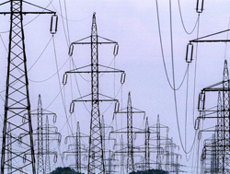
Fig. 1 Transmission lines
Labels of captions are set via the menu “Insert – Caption”, the item “New Label”. In the template, the following captions are used: “Fig.”, “Tab.” and “(”. In case of need, use others.
The simplest way of creating the caption of the figure is to copy some of captions used in this template and only overtype the text. Numbering will change automatically after re-opening the document, or by right button clicking the number and selecting the item “Update Field”. The figure itself (if placed in the text) will be formatted in the style “Obrázek, tabulka – Picture, Table”. It is natural that larger space can be required for the figure than that created by the width of one column. In this case several possibilities exist how to make it:
- To use a suitable picture size.
- To use a floating picture – i.e. the picture that is not placed in the text; in this case it is suitable to insert a caption of the picture as a normal text below the picture and not to insert it to the text field (see Fig. 3). A disadvantage is that the picture is floating, and its location must be “watched”, e.g. by anchoring it to the caption.
- Breaking the two-column flow and inserting a one-column part for the placement of larger figures and also tables and charts. This can be done in several ways again; for simplicity and maintaining the paper structure, the following seems to be best. We shall highlight the blank line in the place where one column is to be inserted as if we want to delete it completely. Then we shall go to the menu “Format – Columns” and select the one column option with specification of applying to “This section”. Subsequently, we shall insert the selected object (figure) into this line; see Fig. 2 (Tab. 1). However, you must have certainly noticed a change in column continuity. It means that the text of the column continues at the right, and only below the one-column object continues at the left side. Nevertheless, this is also standard formatting and is typographically correct.

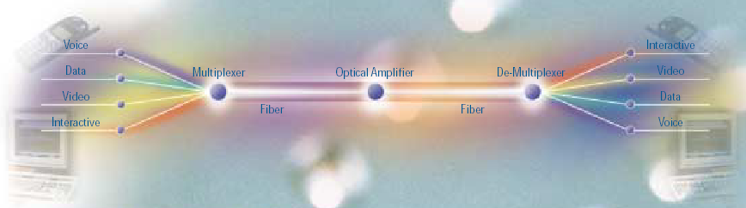
Fig. 2 An example of complexity and simultaneously simplicity of communication (among other matters, the example of inserting the figure to the same width as the page)
Tab. 1 An example of a two-column wide table
Publication | Year | Number | Pages | Total number of copies
 | 1990 | 5 | - | 5
 | 1991 | 20 | - | 40
 | 1992 | 10 | - | 30
 | 1993 | - | - | -
 | 1994 | 1 | - | 10

If you have problems when inserting pictures and tables, it is appropriate to see picture properties being, for illustration, a part of the template. Click on the right mouse button and select the item “Format Picture…”.
Pictures should be black and white, in shades of grey or in colour. The paper will be printed to the PDF format. For the reason of readability, the minimum size of characters in the picture must be considered.
Fig. 3 Power plant “Dukovany”
  - Tables, Numbering and References
Using tables in the text is, in many aspects, equal to that of pictures. If the table exceeds the column width, several possibilities of its insertion exist similar to those with picture insertion. Below Fig. 2, an example of a table adjusted to match the overall width of the document is presented.
Main principles for tables are as follows:
- the caption and numbering according to the procedure given in section 2.3,
- the whole table will be centred over the column (page centre; not valid for tables inserted similarly to Fig. 3),
- the font used in the style of the body of the paper, or centre-aligned. If you use another font, the font size must correspond to the basic style.
  - Equations, Numbering and References
As a fundamental tool for typing relations, equations, and also proofs, the MS Equation editor should be used that is a common component of the MS Office, or MS Word. Equations will be inserted into the text (if they are not part of the paragraph – mostly less important) in the style “*Vztah – Equation*”. This centres the equation over the column after inserting the tab and also right justifies the numbering. If the equation is too wide to fit in the width of one column, it must be run in appropriately. The size of characters in formulae should be proportional to the size of characters of the main text. Units, if required, should be stated in parentheses behind the equation in the below-given format:
$R=\frac{U}{I}$ (Ω;U,I) ()
To the equation formatted like that, any automatic reference cannot be created without problems. To create it, the label of captions “(” must be used for numbering, and this must be placed into the table without borders according to the example, see (). Relations then will be automatically numbered too. It is the most suitable to copy this table for each relation and to insert another formula required by you into it.
$R=\frac{U}{I}$ (Ω;U,I) | ()
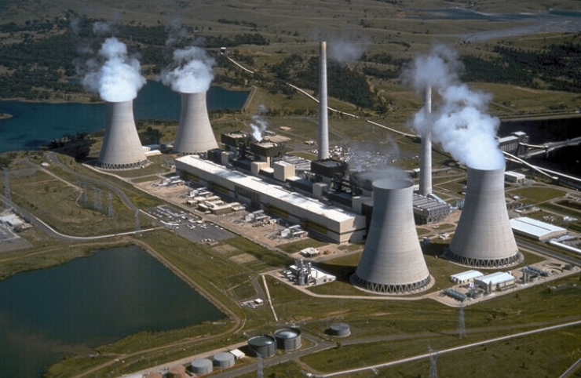
Now we can use interactive references also with relations. The procedure is as follows: from the menu “Insert – Cross-reference” pick the item “(” from captions (if it does not exist, create it), for instance (). We remind, that the automatic fields (numbering) and references are updated by the F9 key after highlighting.
With regard to the font file, it is recommended to type all characters in the text that are not a part of the base font “Times New Roman” by means of the MS Equation (equation editor). Thus we avoid the mistranslation of them, and simultaneously they will be typographically distinguished from the main text.
  - Bibliography and References
The format of bibliography, citations and references in the text is given by the ISO standard. In this template, this is taken into account. Nevertheless, it was not possible to keep always the prescribed style (being possible in the framework of one paper; impossible, however, with the proceedings).
Each citation is of the style “Literatura – Reference Num” and is numbered automatically. This enables the creating of references through the item “Insert – Cross-reference – (numbered item)”, example [1].
- Conclusion
Simultaneously, we retain the right, in case of need or in case of the unsatisfactory appearance of some of contributions, to reformat the contribution without the author’s approval. Typing directly in the template is recommended in any case, otherwise you may type the plain text first and only subsequently format it (best by inserting into the template). Anyhow, you have examples of applications of each format at your own disposal. If you require any change or supplement, please, contact the organizing committee.

At the conclusion, we wish you many imaginative ideas and the patience to process them. Please submit only manuscripts in the form of full papers allotted maximum 6 (six) Proceedings pages.
ACKNOWLEDGEMENTS
In addition, you can express thanks, or you may omit this part completely.
Please, do not delete any characters and separators.
REFERENCES
- Drapela, J., Toman, P. Interharmonic – Flicker Curves of Lamps and Compatibility Lever for Interharmonic Voltages. 2007 IEEE Laussane Powertech, Switzerland. IEEE PES, 2007, 6pp.

